ANNEXURE X – IMPLEMENTATION PLAN

1. PURPOSE & LEGAL STATUS
English
This Annexure X (Implementation Plan) forms an integral and legally binding part of the Master Software License & Implementation Agreement (the “Agreement”). This Annexure defines only the implementation methodology, delivery approach, scope of implementation services, responsibilities of the Parties, timelines, governance, acceptance criteria, assumptions, and dependencies for the implementation of the Enterprise Payroll System.
All commercial terms, pricing, fees, and payment milestones applicable to the implementation services are governed exclusively by the Agreement and/or the applicable Statement(s) of Work (SOWs).
Tiếng Việt
Phụ lục X (Kế hoạch Triển khai) là một phần không tách rời và có giá trị ràng buộc pháp lý của Hợp đồng Cấp phép Phần mềm & Triển khai (“Hợp đồng”). Phụ lục này chỉ quy định phương pháp triển khai, phạm vi dịch vụ triển khai, trách nhiệm của Các Bên, tiến độ, cơ chế quản trị, tiêu chí nghiệm thu, các giả định và trách nhiệm phối hợp liên quan đến việc triển khai Hệ thống Tính lương Doanh nghiệp.
Mọi điều khoản thương mại, giá dịch vụ và các mốc thanh toán liên quan đến dịch vụ triển khai được điều chỉnh riêng theo Hợp đồng và/hoặc Phụ lục Công việc (SOW) tương ứng.

2. DELIVERY APPROACH & METHODOLOGY
English
The implementation shall be delivered using a structured, phased methodology aligned with leading international project management practices (PMBOK / PRINCE2 aligned). Delivery shall be governed through formal stage gates, documented approvals, and audit-ready deliverables, ensuring traceability from business requirements through configuration, testing, and production deployment.
Tiếng Việt
Việc triển khai được thực hiện theo phương pháp phân kỳ, có cấu trúc, phù hợp với các chuẩn quản lý dự án quốc tế. Dự án được kiểm soát thông qua các cột mốc nghiệm thu chính thức, phê duyệt bằng văn bản và hồ sơ sẵn sàng cho kiểm toán, đảm bảo khả năng truy vết từ yêu cầu nghiệp vụ đến cấu hình, kiểm thử và vận hành chính thức.

3. IMPLEMENTATION TIMELINE (INDICATIVE)
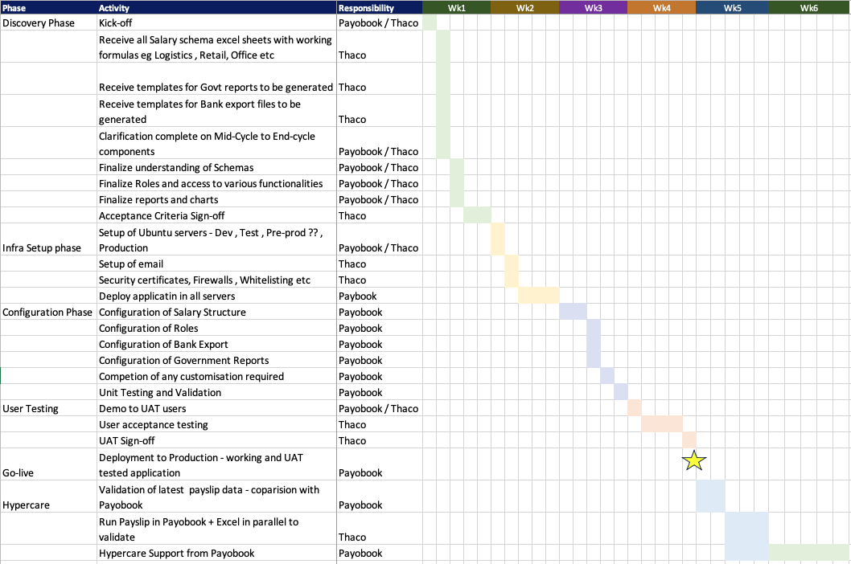
Timeline is indicative and subject to timely Client inputs and approvals. Any delay in Client Dependencies shall result in a corresponding extension of timelines without penalty to the Vendor.

4. IMPLEMENTATION ENVIRONMENTS
The implementation explicitly includes the following environments:
Environment | Purpose | Responsibility
Test / QA Environment | System Integration Testing (SIT) and User Acceptance Testing (UAT) | Vendor & Client
Production Environment | Live payroll processing | Vendor & Client

5. PHASE-WISE IMPLEMENTATION PLAN & RESPONSIBILITIES

Phase 1 – Discovery Phase
Primary Responsibility: Joint (Client & Vendor)
Client Responsibilities
- Nominate project sponsor and authorized decision-makers
- Provide payroll calculation excel document for various salary structures, statutory templates, and bank export formats
- Review and approve scope and assumptions
Vendor Responsibilities
- Conduct project kickoff and governance setup
- Perform requirements analysis
- Assess integrations and data configuration approach
Deliverables
- Signed Scope & Acceptance Criteria

Phase 2 – Infrastructure & Environment Setup
Primary Responsibility: Vendor
Client Responsibilities
- Setup Server and provide access to Vendor
- Configure network rules to open port for application, security certificate for SSL
Vendor Responsibilities
- Configure Test/QA and Production environments
- Deploy application and baseline configuration
- Configure backups, schedulers and access roles
Deliverable
- Environment Readiness Sign-off

Phase 3 – Configuration & Build
Primary Responsibility: Vendor
Client Responsibilities
- Validate payroll rules and statutory interpretations
- Provide timely clarifications and approvals
Vendor Responsibilities
- Configure salary structures, allowances, deductions, and statutory rules based on working excel provided
- Configure bank export & statutory reports based on template provided
- Configure integrations and customizations as needed
- Execute end-to-end payroll and integration testing
Deliverables
- Configured Payroll System (Test Environment)
- Configured system outputs

Phase 4 – User Acceptance Testing (UAT)
Primary Responsibility: Joint
Client Responsibilities
- Execute UAT scenarios and parallel payroll runs
- Provide UAT sign-off
Vendor Responsibilities
- Support UAT execution and issue resolution
- Assist with payroll and statutory reconciliation
Deliverables
- UAT Sign-off

Phase 4A – User Training
Primary Responsibility: Vendor
Training Scope
- Payroll administrators
- Approvers and managers
- IT / support teams
Deliverables
- Training Completion Sign-off
- User Manuals and SOPs

Phase 5 – Go-Live & Production Deployment
Primary Responsibility: Vendor
Client Responsibilities
- Approve cutover and execute business payroll
- Provide Go-Live sign-off
Vendor Responsibilities
- Execute production deployment
- Support first live payroll run
Deliverable
- Go-Live Approval

Phase 6 – Hypercare & Support Transition
Primary Responsibility: Vendor
Scope
- Hypercare support for a defined post Go-Live period
- Issue tracking and stabilization
Deliverables
- Hypercare Closure Confirmation

If needed following activity will need to be scoped and scheduled

Data Migration
Primary Responsibility: Joint
Client Responsibilities
- Confirm migration scope
- Provide cleansed, accurate, and validated source data eg Employee details, Contract details etc
Vendor Responsibilities
- Execute trial and final data migrations
- Prepare reconciliation and validation reports
Deliverables
- Migration Reconciliation Report
- Migration Sign-off
Vendor shall not be responsible for inaccuracies arising from incorrect or incomplete Client-provided data.

6. ACCEPTANCE CRITERIA
- Discovery Phase: Confirmed scope
- Configuration Phase: Payroll rules configured and validated
- Testing Phase: SIT and UAT completed with no critical defects
- Go-Live Phase: Successful production payroll run

7. ASSUMPTIONS & CLIENT DEPENDENCIES
- Client shall provide accurate, complete, and timely data, inputs, and approvals
- Statutory or regulatory changes after Solution Design sign-off shall be managed via Change Request
- Delays caused by Client dependencies shall extend timelines accordingly
- Master Data migration if required would need to be scoped and scheduled separately

8. CHANGE CONTROL
Any deviation from the agreed implementation scope, timelines, or deliverables shall be governed by the Change Request (CR) process defined in the Agreement.

9. RACI SUMMARY
Activity | Client | Vendor | Joint
Requirements | A | R | C
Configuration & Build | C | R
Data Migration (of master data if needed ) | R | R | C
Testing (SIT/UAT) | R | R | C
Go-Live | A | C | R
Hypercare & Transition | C | R

10. ORDER OF PRECEDENCE
This Annexure X is subject to the order of precedence set out in the Agreement. In the event of any inconsistency, the terms of the Agreement shall prevail.

Acknowledged and Agreed
For Client: ________________________ Date: _______
For Vendor: ________________________ Date: _______

